Operations processes

- Inputs
Inputs are the resources used in the transformation (production) process. Common direct inputs include: labour, energy, raw materials, machinery and technology.
- Transformed resources (materials, information, customers)
Transformed resources are those inputs that are changed or converted in the operations process.
Materials: are the basic elements used in the production process and consist of two types; raw materials and intermediate goods. Raw materials are the essential substances in their unprocessed state. Intermediate goods are goods manufactured and used in further manufacturing or processing. In a service based business, items such as stationary, computers, furniture and tools-of-trade are outputs of other businesses but become essential inputs to the delivery of a service.
Information: is the knowledge gained from research, investigation and instruction, which results in an increase in understanding. Its main value is in its ability to influence decision making. Information acts as a transformed resource when it is used to inform how inputs are used, where they are drawn from, which suppliers and supplies are available and so on. That is, the information is in a form htat needs to be understood or analysed, not compiled.
Customers: become transformed resources then their choices shape inputs. A consumer orientation takes the preferences and interests of consumers as the starting point in the production process. In this way, a consumer acts as an input and their preferences act as a transformed resource.
- Transforming resources (human resources, facilities)
Transforming resources are those inputs that carry out the production process. They enable the change and value adding to occur.
Human resources: employees are said to be the most important input into business. Staff that are well qualified, hard working and disciplined can bring great productivity and efficiency to business operations. The effectiveness with which human resources carry out their work duties and responsibilities can determine the success with which transformation and value adding occurs. Well designed human resource management policies and practices can improve the performance of the operations processes.
Facilities: refer to the plant (factory) and machinery used in the operations processes. The plant and machinery can make a very significant difference to a business and its capacity to transform. Clearly the facilities can determine the nature of the operations environment.

- Transformation processes
Transformation is the conversion of inputs (resources) into outputs (goods and services). It is important to understand that the transformation process differs between manufacturing businesses and service businesses. A manufacturer transforms inputs into tangible products, whereas a service organisation transforms inputs into intangible products. The operations process of a manufacturer tends to be highly automated or mechanised. Service providers rely heavily on interaction with the customer and their processes tend to be more labour-intensive (staff are more crucial to operations). Transformation processes are also directly involved with value adding. Costs are incurred when something created by manufacturing is processed or a service is created.
- The influence of volume, variety, variation in demand and visibility (customer contact)
Decisions will need to be made about the following questions:
- How much to make – what volume of input to draw in and to process?
- How much variation – what range of outputs should be made in the process of transformation?
- How much variation in demand will there be – how can operations processes respond to changes in demand?
- How much customer contact should there be and what, if any, role should it have on transformation processes?
Volume: refers to how much of a product is made. Volume flexibility refers to how quickly the transformation process can adjust to increases or decreases in demand, called a lead time. if a business cannot quickly adjust to changes in market demand, it can over produce, which may lead to wastage and increased inventory costs. Alternatively, if back orders cannot be quickly fulfilled, it can lead to lost sales.
Variety: is the mix of products made or services delivered through the transformation processes, sometimes called mix flexibility. Te influence of variety on the transformation processes is the greater variety made, the more the operations processes need to allow for variation.
Variation in demand: an increase in demand will require increased inputs from suppliers, increased human resources, increased energy use and increased use of machinery and technology. However it may be hard to meet it suppliers cannot supply quickly enough, labour is not flexible, skilled or available, machinery cannot adapt to increased capacity or increased power is not able to be sourced. All businesses will try to forecast demand so that adjustments can be anticipated and a business can act accordingly. Seasonal factors cause predictable variations in demand such as Christmas.
Visibility (customer contact): or ‘feedback’ can directly affect transformation processes. This is because customer preferences an shape what businesses make. Customer contact can be direct or indirect. Because businesses seek to maximise sale, customer contact is essential and ultimately shapes the transformation process.

- Sequencing and scheduling – Gantt charts, critical path analysis
Sequencing refers to the order in which activities in the operations processes occur. Scheduling refers to the length of time activates take within the operations processes. An understanding of both sequencing and scheduling is necessary for operations managers.
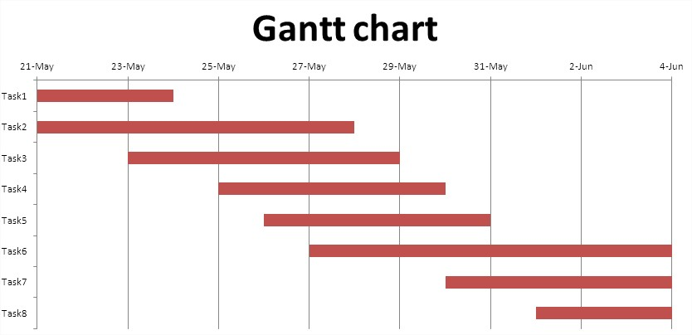
Gantt charts: Is a type of bar chart that shows both the scheduled and completed work over a period of time. it is often used in planning and tracking a project. The two main advantages of Gantt charts are they force a manager to plan the steps and time needed to complete a task, and they make it easy to monitor actual progress.

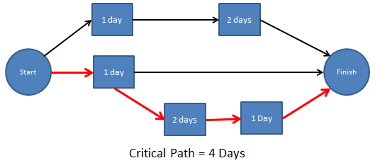
Critical path analysis (CPA): is a scheduling method or technique that shows what tasks need to be done, how long they take and what order is necessary to complete those tasks.
The critical path shows the shortest length of time it takes to complete all tasks necessary. It is clear from this type of analysis that scheduling enables a manager to see when needs to be done and allows the timing of tasks to be considered. With this information, a business will be able to see in what order activities need to be done. They will also be able to see which tasks can be done at the same time.

- Technology, task design and process layout
Technology: Generally, technology is the application of science or knowledge that enables people to do new things or perform established tasks in new and better ways. The business technology involves the use of machinery and systems that enable businesses to undertake the transformation processes more effectively and efficiently. Most technology impacts every aspect of business, assisting employees to work more productively. The capital cost of technology is relatively high, so businesses need to decide whether to purchase technology or lease it. Leasing is more common because it is cheaper which allows money to be saved to be spent elsewhere.
Office technology includes computers, printers, modems, pagers, scanners and photocopiers etc. developments of these have created the opportunity for people to do more work in less time, which means a greater range of tasks can be completed in their working time. Manufacturing technology includes robotics, CAD and CAM.
Task design: involves classifying job activities in ways that make it easy for an employee to successfully perform and complete the task. It overlaps with the employment relations function of job analysis, job description and person specification. Typically there is a separation between manufacturing and administrative operations. In task design, it is necessary to group skills and competence because this helps when obtaining staff. Attracting the right candidate for the task is the final part of a process that starts with task design and ends with selection: task design job description person specification recruitment selection. A business may formalise the task design process while a job is already being done. Under these circumstances it is usual for the task to be analysed to see whether it could be done more efficiently. A skills audit is a formal process used to determine the present level of skilling and any skill shortfalls that need to be made up either through recruitment or training.
Plant (factory/office) layout: is the arrangement of equipment, machinery and staff within the facility (either a factory or an office). Design and layout has an impact on the efficiency on operations.
Process layout: is the arrangement of machines such that the machines and equipment are grouped together by the function or process they perform, eg in a hospital. Process production deals with high variety, low volume production.
Product layout: is where the equipment arrangement relates to the sequence of tasks performed in manufacturing a product. Product production (mass production) is characterised by the manufacturing of a high volume of constant quality goods, often characterised by production/assembly lines, eg the production of TV’s or motor vehicles.
Fixed position layout: is an operational arrangement in which the employees and equipment come to the product eg construction.
Office layout: enables the work to be performed efficiently in a safe environment, tailored to the needs of the business.
- Monitoring, control and improvement
All operations processes should be monitored for their effectiveness. The main transformational processes should be subject to control, which requires effective monitoring and a focus on continual improvement.
Monitoring: is the process of measuring actual performance against planned performance. During operations processes monitoring is crucial, as it involves measuring all aspects of operations, from supply chain management to the use of inputs through to the transformation process and outputs.
Control: occurs when key performance indicators are assessed against predetermined targets and corrective action is taken if required. Control requires operations managers to take corrective action, that is, making changes to the transformation processes such as redesigning the facilities layout or adjusting the level of technology in order to correct the problem.
Improvement: refers to systematic reductions of inefficiencies and wastage, poor work processes and the elimination of any bottlenecks. It is usually sought in the following areas:
- Time – through the minimising of bottlenecks, an assessment of necessity in the production processes and wait times
- Process flows – and smoothness of transition between transforming processes
- Quality – through the pursuit of quality goals, measurement of product standards and quality and assessment of returns or warranties
- Cost – through an assessment of per unit costs of production, delivery, and a review of fixed and variable costs
- Efficiency – through the reduction of wastes and the creation of greater output per unit input
- Outputs
Outputs refer to the end result of the business efforts – the good or service that is provided or delivered to the customer. Output must always be responsive to customer demands. Issues of quality, efficiency and flexibility must be balanced against the resources and strategic plan of the business. There are more subtle outputs than the actual good or service provided. Customer service refers to how well a business meets and exceeds the expectations of customers in all aspects of its operations. Warranties are a business’s promise to correct and defects in their products or in the services they deliver.
- Customer service
Customer service refers to how well a business meets and exceeds the expectations of customers in all aspects of its operations. Central to customer service is to make sure the right good or service is delivered or provided at the right place at the right time. to keep existing customers and attract new ones, the business needs to talk and listen to their customers. Customer service is now regarded as an attitude that should be adopted by all departments and employees within the business.
- Warranties
A warranty is a promise made by a business that they will correct an defects in the goods that they produce or in the services that they deliver. Warranty claims are made against goods that have defects arising from an issue in transformation. Rectifying faults costs money. Operations managers need to trace the source of the fault in manufacturing and rectify it. In this way, warranty claims lead the business to improve transformation processes.

